Press release from AECO - Association of Arctic Expedition Cruise Operators (for immediate release):
Longyearbyen launches first community specific tourism guidelines
This month, Longyearbyen became the first Arctic town to launch its own community specific guidelines. The guidelines instruct tourists on how to be considerate visitors and were developed using a template created by the Association of Arctic Expedition Cruise Operators (AECO) and partners.
When you visit Longyearbyen, you are encouraged to do as the locals: respect wildlife, nature and each other. The Arctic town has now launched new guidelines for tourists visiting their community. The guidelines offer tips and tricks to get around and advice on how to be a considerate guest.
Among other things, the guidelines encourage visitors to chat with locals, but to ask before taking photos and to respect people’s privacy. Visitors are invited to support the community by shopping locally but are reminded that there is no tradition for bargaining in Svalbard. Tourists are also given useful pointers on which side of the roads they should walk on if there’s no sidewalk and how they can help keeping Svalbard clean by using garbage bins.
The guidelines were created by Visit Svalbard, Port of Longyearbyen and Svalbard Cruise Network with funding from NORA (North Atlantic Cooperation).
“Longyearbyen is a popular tourist destination and these guidelines will help visitors understand our town. Tourists often visit for a short period, and these community guidelines are a great way of communicating local knowledge directly to visitors,” says Ronny Brunvoll, general manager of Visit Svalbard.
Frigg Jørgensen, executive director of AECO, hopes that more Arctic towns and hamlets will embrace the concept of community specific guidelines.
“AECO has created general community guidelines that provide travelers with useful dos and don’ts when visiting Arctic communities. We also created a template allows communities create their own tailored guidelines, and we are happy to see Longyearbyen become the first town to make this a reality,” says Jørgensen.
Longyearbyen’s community specific guidelines are available on the webpages of Visit Svalbard and AECO.

Suggested illustration photos
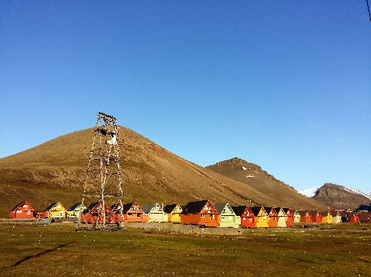 | Photo caption: The new guidelines tell visitors what they should know when visiting Longyearbyen, the northernmost town in the world. (Photo: Frigg Jørgensen, AECO)  High resolution illustration image can be downloaded here: https://www.dropbox.com/sh/wldwo3hnqncqhju/AADUai00raYLYfD7Z5NENF_Ra?dl=0
AECO - Association of Arctic Expedition Cruise Operators
Association of Arctic Expedition Cruise Operators is an international organization for expedition cruise operators and associates in the Arctic, dedicated to managing environmentally friendly, safe and considerate cruise tourism. With close to 70 international members – including 40 vessel operators, owners and management, and 50 expedition cruise vessels that are organized by the association – AECO represent the great majority of these operations in the Arctic.
Website: www.aeco.no.
Visit Svalbard
Visit Svalbard AS is owned by Svalbard Reiselivsråd, which is a member-based organization for the travel industry in Svalbard. The company’s vision if for Svalbard to be the world’s leading and best preserved High Arctic travel destination. This will be achieved through deliberate development based on and considerate of the peninsula’s fragile nature, with a focus of environment and knowledge-based tourism. Visit Svalbard’s activities include marketing, promotion and selling Svalbard as a destination. Visit Svalbard also functions as a secretariat for all of the travel industry in Longyearbyen.
Website: www.visitsvalbard.com
NORA
NORA (North Atlantic Cooperation) is an intergovernmental organization under the regional cooperation programme of the Nordic Council of Ministers and it brings together Greenland, Iceland, Faroe Islands and Coastal Norway. The organization builds on the West Nordic cooperation founded in 1981 and became NORA when Coastal Norway joined in 1996. The NORA countries are interlinked by their geographic location, shared traits and common challenges, in addition to multiple historical, institutional and cultural ties. Website: https://nora.fo/

